Computer Networking

Assignment 2

Deadline Nov. 26, 2023

**Submission format: submit your solution in a PDF file to blackboard under Assignment Section, as long as it is clear enough for grading. Comment your name and student number in the submission**

Problem 1: UDP (20 points)

UDP and TCP use 1s complement for their checksums. Suppose you have the following three 8-bit bytes: 01010011, 01100110, 01110100. What is the 1s complement of the sum of these 8-bit bytes? (Note that although UDP and TCP use 16-bit words in computing the checksum, for this problem you are being asked to consider 8-bit sums.) Show all work. Why is it that UDP takes the 1s complement of the sum; that is, why not just use the sum? With the 1s complement scheme, how does the receiver detect errors? Is it possible that a 1-bit error will go undetected? How about a 2-bit error?

Problem 2: Reliable Data Transfer (10 points)

Consider our motivation for correcting protocol rdt2.1. Show that the receiver, shown in Figure 1, when operating with the sender shown in Figure 2, can lead the sender and receiver to enter into a deadlock state, where each is waiting for an event that will never occur.

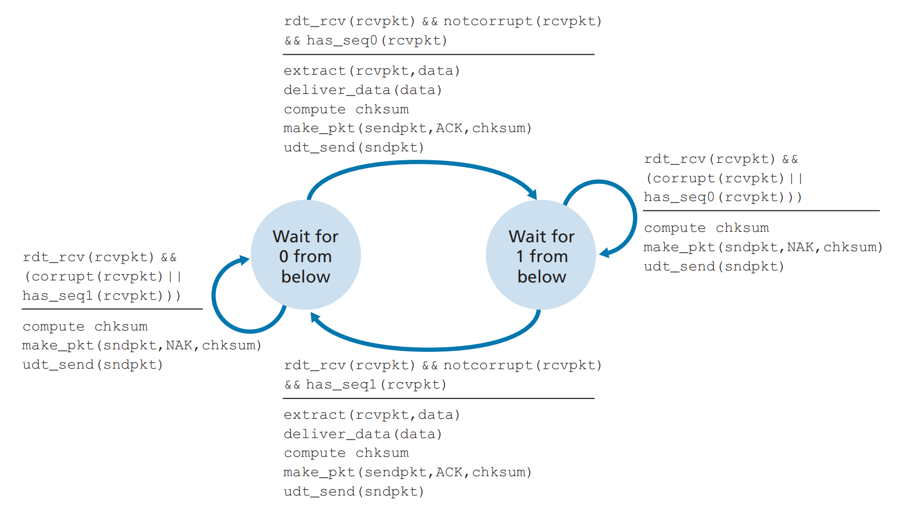

Figure 1: An incorrect receiver for protocol rdt 2.1

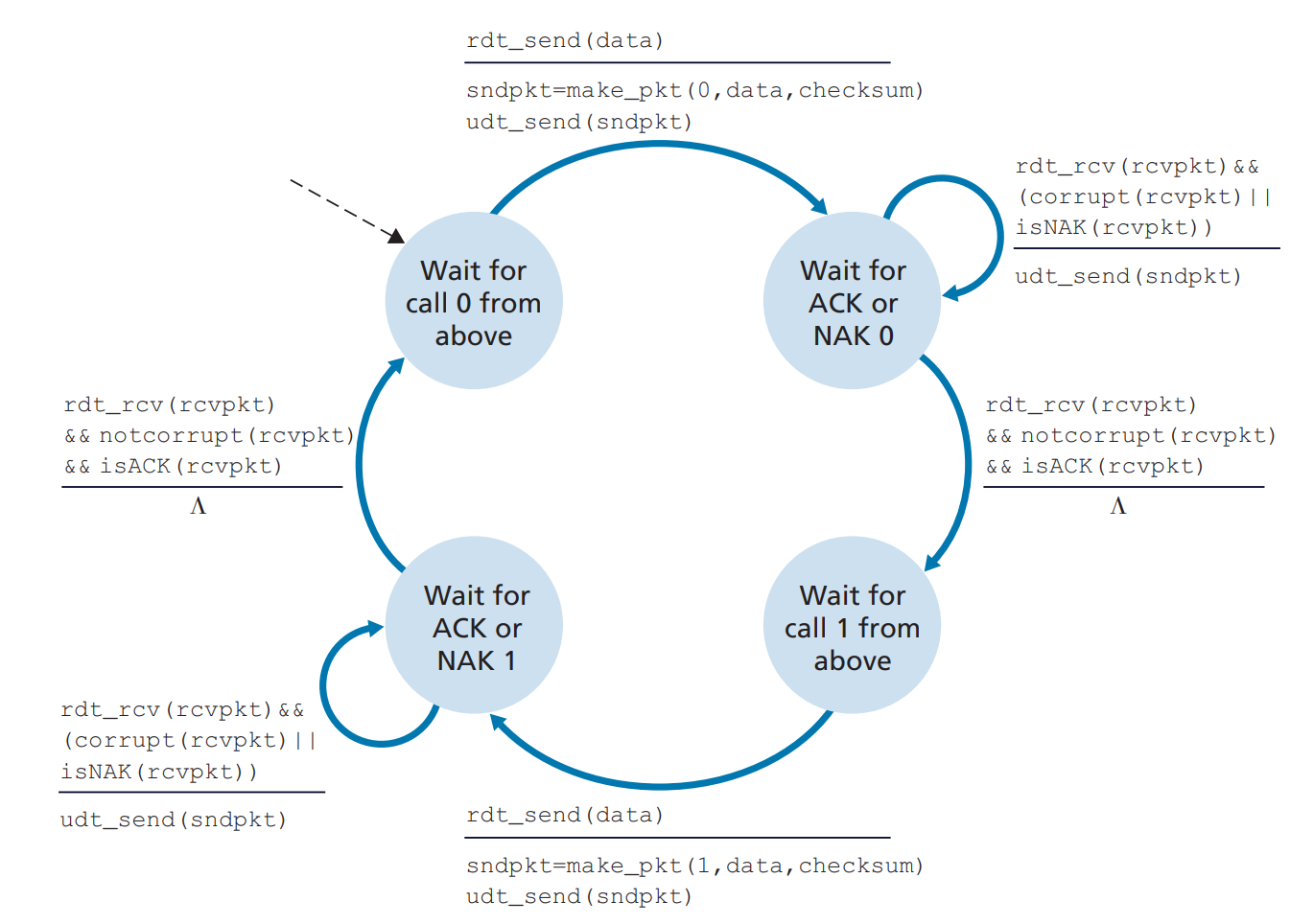

Figure 2: rdt2.1 sender

Problem 3: Pipelining (20 points)

Consider the GBN protocol with a sender window size of 4 and a sequence number range of 1,024. Suppose that at time *t*, the next in-order packet that the receiver is expecting has a sequence number of *k*. Assume that the medium does not reorder messages. Answer the following questions:

1. What are the possible sets of sequence numbers inside the sender’s window at time *t*? Justify your answer.
2. What are all possible values of the ACK field in all possible messages currently propagating back to the sender at time *t*? Justify your answer

Problem 4: TCP (20 points)

Compare GBN, SR, and TCP (no delayed ACK). Assume that the timeout values for all three protocols are sufficiently long such that five consecutive data segments and their corresponding ACKs can be received (if not lost in the channel) by the receiving host (Host B) and the sending host (Host A) respectively. Suppose Host A sends five data segments to Host B, and the second segment (sent from A) is lost. In the end, all five data segments have been correctly received by Host B.

1. How many segments has Host A sent in total and how many ACKs has Host B sent in total? What are their sequence numbers? Answer this question for all three protocols
2. If the timeout values for all three protocol are much longer than 5 RTT, then which protocol successfully delivers all five data segments in shortest time interval?

Problem 5: Congestion Control (30 points)

Consider Figure 3. Assuming TCP Reno is the protocol experiencing the behavior shown above, answer the following questions. In all cases, you should provide a short discussion justifying your answer.

1. Identify the intervals of time when TCP slow start is operating.
2. Identify the intervals of time when TCP congestion avoidance is operating.
3. After the 16th transmission round, is segment loss detected by a triple duplicate ACK or by a timeout?
4. After the 22nd transmission round, is segment loss detected by a triple duplicate ACK or by a timeout?
5. What is the initial value of ssthresh at the first transmission round?
6. What is the value of ssthresh at the 18th transmission round?
7. What is the value of ssthresh at the 24th transmission round?
8. During what transmission round is the 70th segment sent?
9. Assuming a packet loss is detected after the 26th round by the receipt of a triple duplicate ACK, what will be the values of the congestion window size and of ssthresh?
10. Suppose TCP Tahoe is used (instead of TCP Reno), and assume that triple duplicate ACKs are received at the 16th round. What are the ssthresh and the congestion window size at the 19th round?
11. Again suppose TCP Tahoe is used, and there is a timeout event at 22nd round. How many packets have been sent out from 17th round till 22nd round, inclusive?

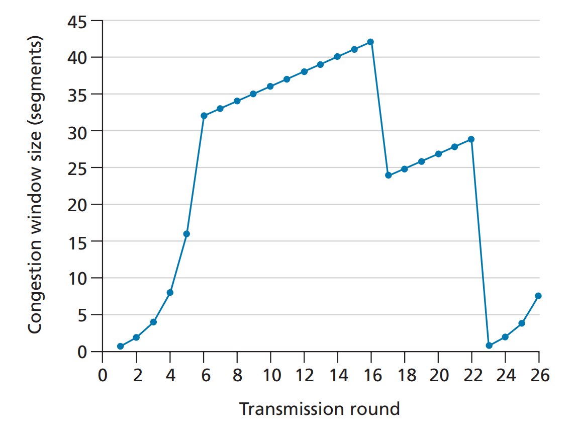

Figure 3: TCP window size as a function of time